VDC R&D Script

1. Download Python 3.7 installer and open the .exe file.
   1. DO NOT click install right after opening the .exe file. Check step 2 first.
   2. <https://www.python.org/downloads/>

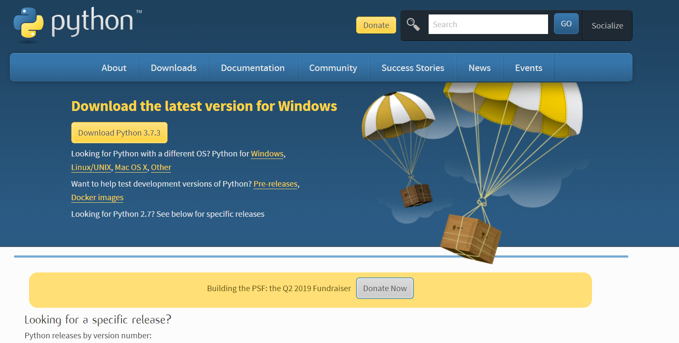

1. During installation, make sure to click the box labelled “Add Python 3.7 to PATH”

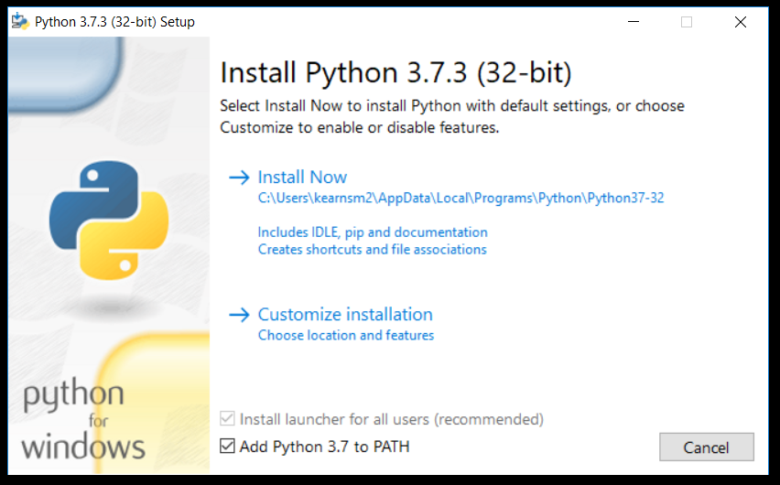

1. Click the “Install Now” option. If prompted to disable the path limit, disable it.
2. After that is installed, open the command prompt by typing “cmd” in the windows search bar on the bottom left of your screen.
3. In the command prompt, type “python”.
   1. This will check to see if python is installed properly. The response should look like the image below.

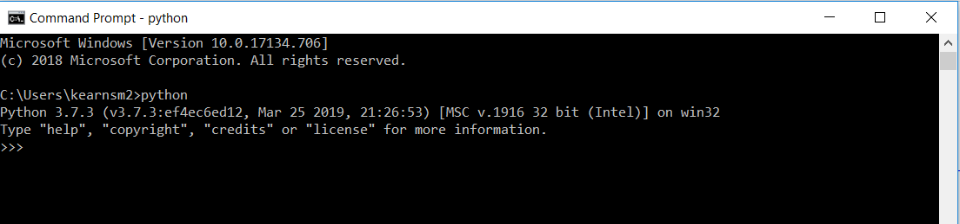

1. Close the command prompt
2. The program requires the following packages:
   1. smartsheet-python-sdk
   2. pysimplegui
   3. xlwt
3. Use “pip” to install the required packages:
   1. In command prompt type “pip install smartsheet-python-sdk” and hit enter to install.
   2. After that is installed, type “pip install pysimplegui” and hit enter.
   3. Do the exact same for xlwt. Type “pip install xlwt” and press enter.
   4. These commands will output information on the download and install of the package.
   5. See Below for examples of what the inputs and outputs of the Command Prompt should look like.

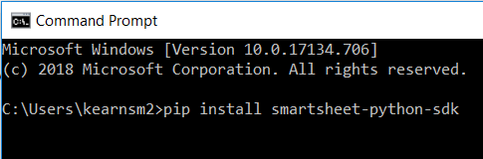

Pip install using Command Prompt

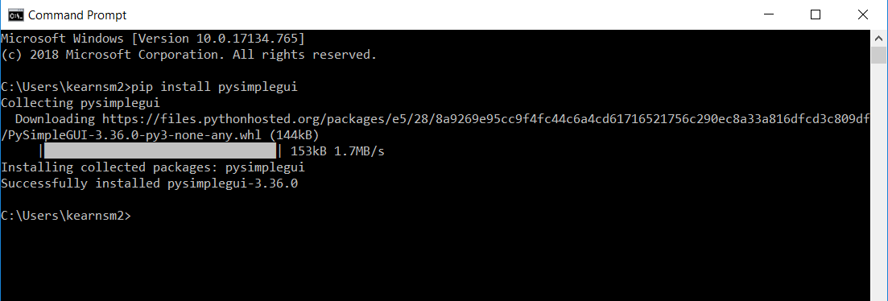

Pip install of PySimpleGUI. The only user input is “pip install pysimplegui”, everything else is printed by the Command Prompt

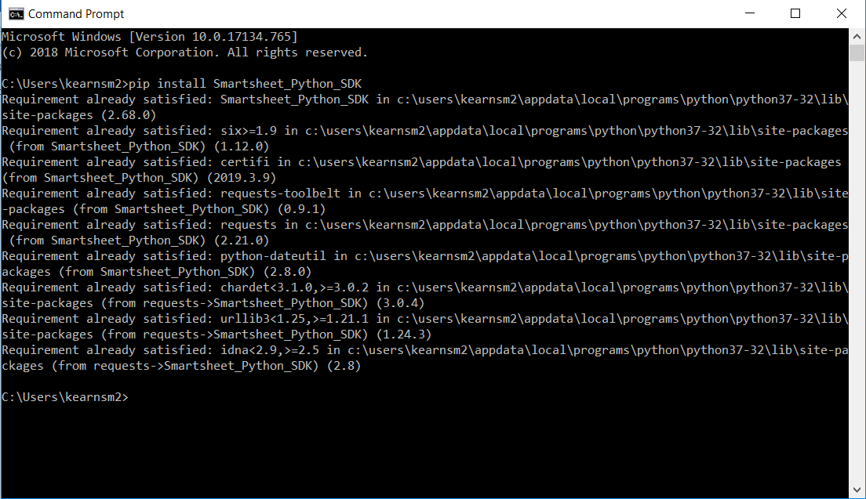

Example of what happens when you already have a package installed. The only thing the user typed here was “pip install Smartsheet-Python-SDK”, everything else is printed by the Command Prompt.

1. Download Python script from box.com
   1. <https://nengvdc.box.com/s/r0s6f9y9xjiiohn744z8nr50wpdtvqrx>
2. Double click on the python script (Should be “VDC R&D Script.pyw”)
   1. If prompted to choose what to open the file with, select “Python”
3. Choose what operation you want to perform

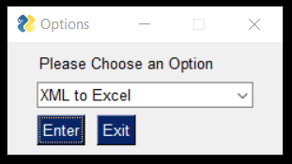

* 1. XML to Excel
     1. XML File: Use “Browse” button to navigate to the XML File you exported from Navisworks.
     2. New Excel File Location: Use “Browse” button to choose location of the new Excel file. This Excel file will have the information from your viewpoints in it.
     3. New Excel File Name: Use the textbox to give a name to your new Excel file. You must name the Excel file.

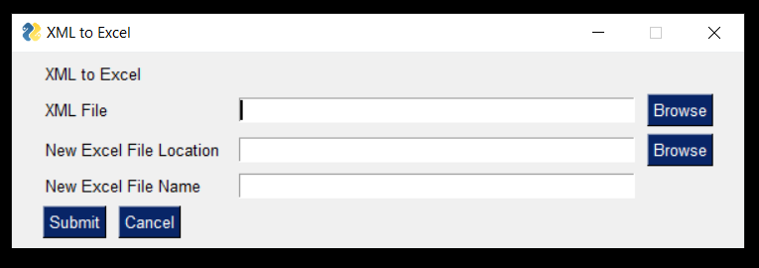

* 1. Image Rename
     1. XML File: Use “Browse” button to select the XML File you exported from Navisworks
     2. Image Folder: Use “Browse: button to select the folder with the viewpoints report from Navisworks
        1. Be sure to delete the “.html” file from the folder

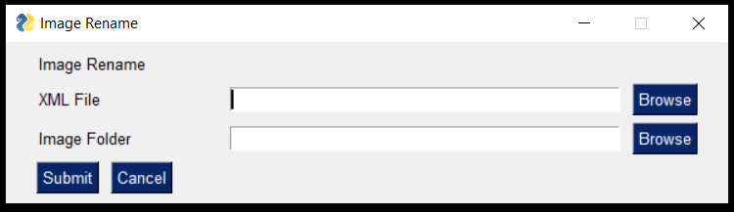

* 1. Smartsheet Image Upload
     1. API Token
        1. Can be created under personal settings on smartsheet website
        2. After generating API Token, be sure to save it somewhere
     2. Sheet ID
        1. Can be found under the properties section of a sheet
           1. Click on File >> Properties when viewing a sheet
           2. Right click on sheet >> Properties
     3. Image Folder Path: Use the “Browse” button to locate the folder that contains all your exported images from Navisworks. If you did not rename your images, remember to delete the “.html” file before beginning the upload.
     4. Start Row
        1. Whatever Row you want your images to begin uploading at
           1. Each image will have a prefix, showing the row number it is attached to
           2. All images must be uploaded sequentially

